**AMERICAN INTERNATIONAL UNIVERSITY-BANGLADESH**

.

|  |  |
| --- | --- |
| Assignment Title: | Map Coloring |
| Assignment No: | 02 Date of Submission: 29 October 2021 |
| Course Title: | Design and Analysis of Algorithm |
| Course Code: | 01562 Section: |
| Semester: | Fall 2020-21 Course Teacher: DR. M M MANJURUL ISLAM |

**Declaration and Statement of Authorship:**

1. I/we hold a copy of this Assignment/Case-Study, which can be produced if the original is lost/damaged.
2. This Assignment/Case-Study is my/our original work and no part of it has been copied from any other student’s work or from any other source except where due acknowledgement is made.
3. No part of this Assignment/Case-Study has been written for me/us by any other person except where such collaboration has been authorized by the concerned teacher and is clearly acknowledged in the assignment.
4. I/we have not previously submitted or currently submitting this work for any other course/unit.
5. This work may be reproduced, communicated, compared and archived for the purpose of detecting plagiarism.
6. I/we give permission for a copy of my/our marked work to be retained by the Faculty for review and comparison, including review by external examiners.
7. I/we understand that Plagiarism is the presentation of the work, idea or creation of another person as though it is your own. It is a formofcheatingandisaveryseriousacademicoffencethatmayleadtoexpulsionfromtheUniversity. Plagiarized material can be drawn from, and presented in, written, graphic and visual form, including electronic data, and oral presentations. Plagiarism occurs when the origin of them arterial used is not appropriately cited.
8. I/we also understand that enabling plagiarism is the act of assisting or allowing another person to plagiarize or to copy my/our work.

*\* Student(s) must complete all details except the faculty use part.*

** Please submit all assignments to your course teacher or the office of the concerned teacher.

|  |  |  |  |  |  |
| --- | --- | --- | --- | --- | --- |
| **No** |  | **Name** | **ID** | **Program** | **Signature** |
| 1 | Jakaria Islam Emon |  | **21-92037-2** | MSCS |  |

|  |  |  |
| --- | --- | --- |
| ***Faculty use only*** |  | |
| FACULTYCOMMENTS | **Marks Obtained** |  |
|  |
|  |
|  | **Total Marks** |  |
|  |
|  |

Assignment/Case-Study Cover; © AIUB-2020

Map coloring, using four colors

Input Image of a MAP: (The input image background and borders should be white.)

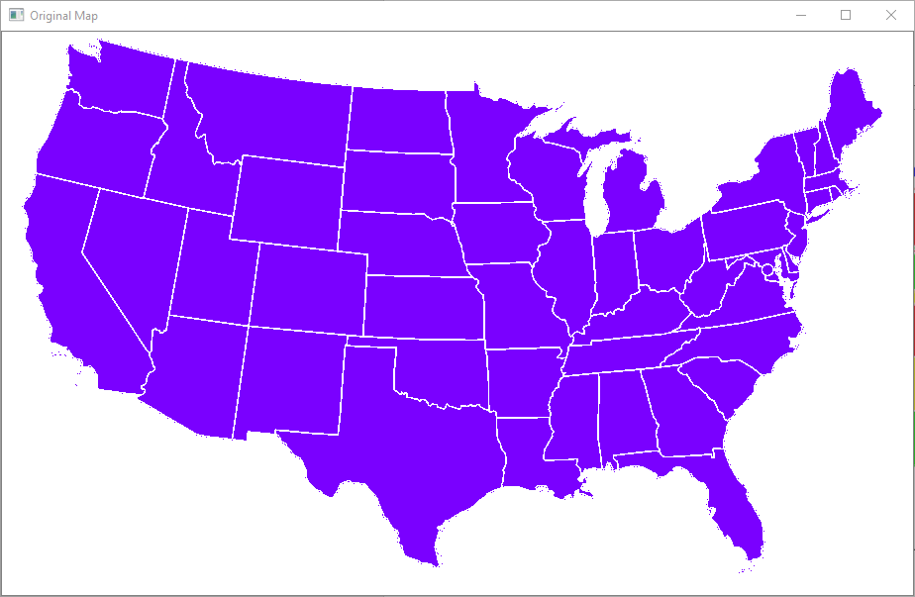

Output Map: (This program gets a map image as an input and produces all possible valid colorings of that map using backtracking.)

Variable explorer after running on USA.PNG file

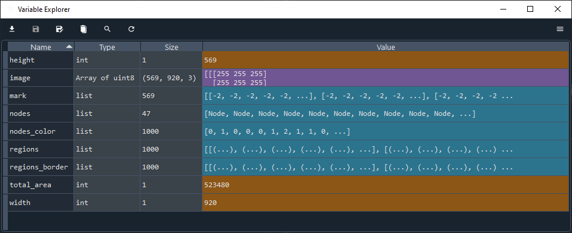

Algorithm

1. Detecting all non-white regions (e.g., provinces or states).

2. Converting the input map to a simple planar graph:

There will be a node for each region. Two nodes will be adjacent, if and only if their corresponding regions have a common border on the map.

3. Using backtracking for [coloring] that graph (it's a recursive function that produces all valid colorings).

4. Displaying all produced colorings on the given map.